Koby Manning

ISM 4212 Assignment 2: Course Management Database

7/27/2023

1. The two intermediary tables will have the student id and course id, and the instructor id and course id respectively.
   1. STUDENTCOURSES(STUDENT_ID, COURSE_ID)
   2. INSTRUCTORCOURSES(INSTRUCTOR_ID, COURSE_ID)
2. A screenshot of a computer

   Description automatically generated
3. TABLES
   1. COURSES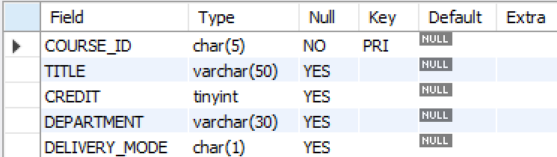
   2. STUDENTS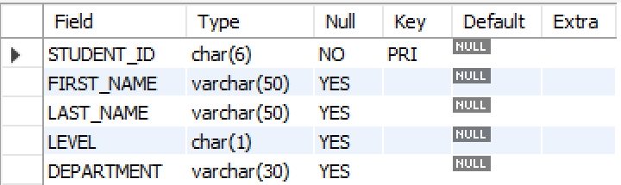
   3. INSTRUCTORS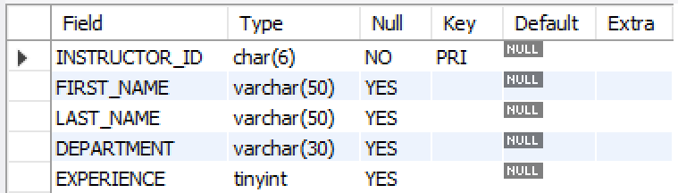
   4. STUDENTCOURSES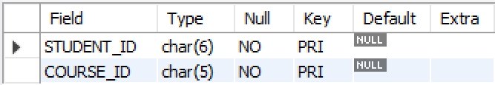
   5. INSTRUCTORCOURSES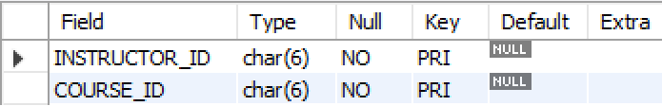
4. Data Entry
   1. STUDENTSA screenshot of a computer

      Description automatically generated
   2. INSTRUCTORSA screenshot of a computer

      Description automatically generated
   3. COURSESA screenshot of a computer

      Description automatically generated
5. A screenshot of a computer

   Description automatically generated
6. A screenshot of a computer

   Description automatically generated
7. A screenshot of a computer

   Description automatically generated
8. A screenshot of a computer

   Description automatically generated
9. VIEWS
   1. A screenshot of a computer

      Description automatically generated
   2. A screenshot of a computer

      Description automatically generated
   3. A screenshot of a computer

      Description automatically generated
   4. A screenshot of a computer

      Description automatically generated
   5. A screenshot of a computer

      Description automatically generated
10. A screenshot of a computer

    Description automatically generated
11. A screenshot of a computer

    Description automatically generated
    1. Gail Park – 8 students
    2. Colin Sutherland – 3 students
    3. Raees Owen – 3 students
    4. Myles Stein – 6 students
    5. Lara Pham – 8 students